Documentation Library Management

In this test, I use the database schema according to what is stated in the Database Schema section. All API Endpoints are compliant and can be tested through postman or PHPUnit Test, for performance optimization itself in this test using a cache with Redis stored with their respective keys within 2 minutes.

Here I attach the results of testing when hitting a request using postman and PHPUnit directly

Perform PHPUnit Test

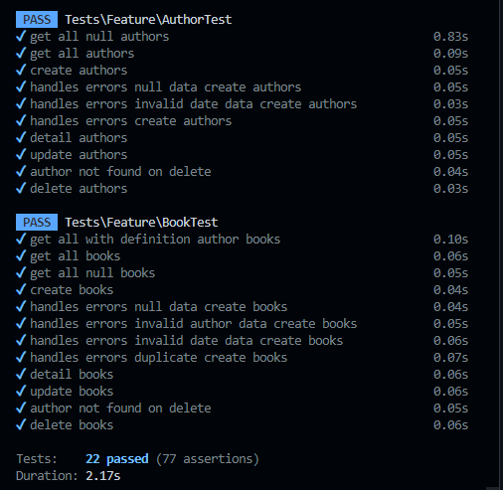

Before Redis Cache

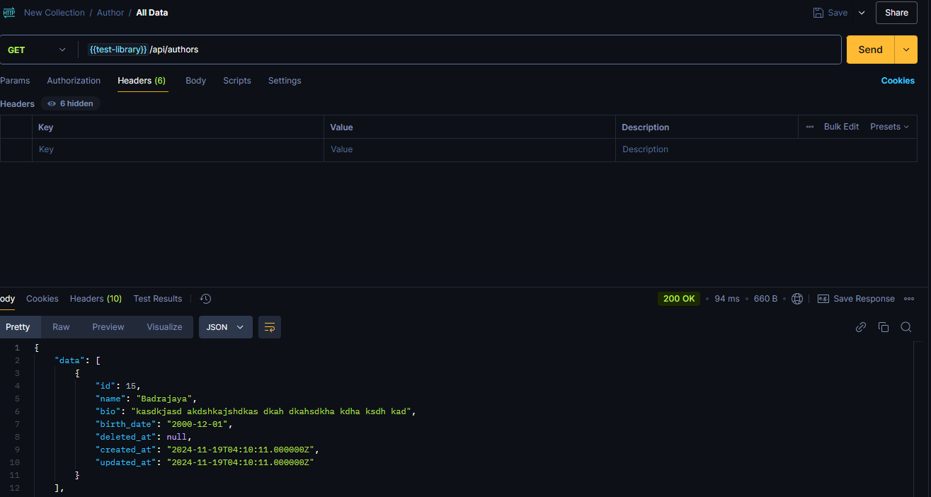

After Redis Cache

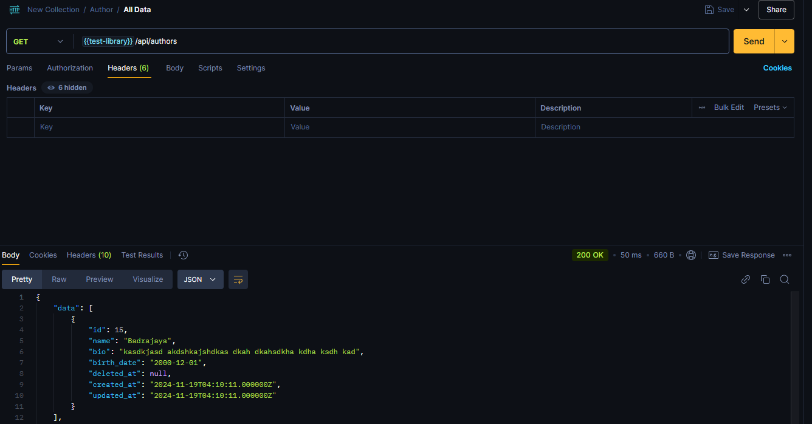

Sample redis after hit GET /authors

